**Shoppers Stop’s latest campaign *Hum Hai Roshni* brings a beam of hope this Diwali**

**National, November 2nd, 2020:** This year’s festive season has a special significance. It’s both a celebration and a mental liberation from the difficult period we have been through. And it dovetails the festival of lights with the ray of light that we welcome back to our lives. Shoppers Stop’s latest campaign *Hum Hai Roshni* for Diwali creates a positive sentiment in the midst of this pandemic.

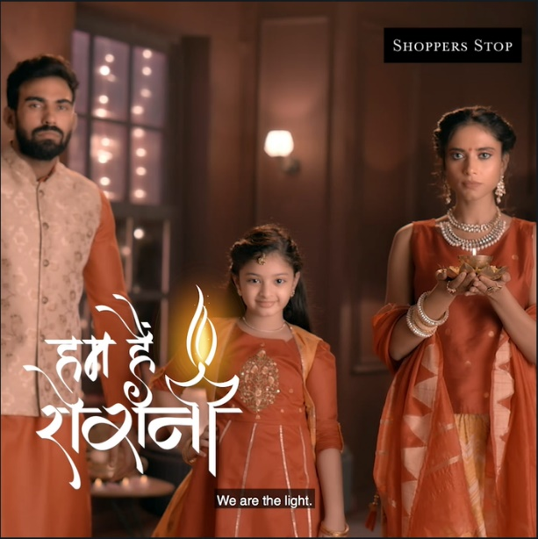Shoppers Stop celebrates this festive season as a celebration of families who come together in these difficult times and rise above, with positivity. This power to overcome comes from within all of us. And Hum Hain Roshni is a metaphor of this power. The film inspires us to find this brilliance within all of us and usher in the festive season.

Sharing her thoughts on the campaign, **Uma Talreja – Customer Care Associate, Chief Marketing and Customer Officer at Shoppers Stop Ltd.** said, *“As we progress through different stages of Unlock, it is important to be cautious and safe while we try to reclaim a sense of normalcy in a way. The film empowers us to overcome dark times and retain our values, culture, and togetherness. This Diwali, Shoppers Stop offers safe shopping at stores and also digital assistance on WhatsApp and through the website and app.”*

Celebrate Diwali safely through Shoppers Stop’s various initiatives that make shopping, an easy, quick, and comfortable experience for you. Use their White Glove service where dedicated Personal Shoppers and now even Beauty Advisors are exclusively available to help you meet your fashion and beauty needs over WhatsApp. Digital services like Endless Aisle, Express Store pick-up (Click n Collect), and Ship From Store on the [**website**](http://www.shoppersstop.com) too can provide quick and helpful solutions to one’s shopping desires.

Shoppers Stop is running offers for its customers across multiple categories such as [**apparel**](https://www.shoppersstop.com/search/?sort=topRated&q=Display_Festiveethnicwear%3AnewArrival-desc%3AinStockFlag%3Atrue%3Al1category%3AAll&startRange=&endRange=&icid=ethnic20201020|homepg|carousal|diwali), [**home décor**](https://www.shoppersstop.com/homeware/c-A80?icid=home20201020|homepg|5widget|festivehomes), [**fashion accessories**](https://www.shoppersstop.com/women-accessories-fashion-accessories/c-A2020130#utm_source=PR&utm_medium=Durgapuja&utm_campaign=300920), and [**kitchen wear**](https://www.shoppersstop.com/homeware-kitchen/c-A8020#utm_source=PR&utm_medium=Durgapuja&utm_campaign=300920). Additionally, there is a First Citizen enrolment drive through differential offering during the festive season. Customers can avail offers and discounts on bedsheets and bed in bag from [Treasures](https://www.shoppersstop.com/search/?text=treasures)/[Fern](https://www.shoppersstop.com/brand/fern), [Noritake dinner set](https://www.shoppersstop.com/homeware-dining/c-A8025?q=%3AtopRated%3AinStockFlag%3Atrue%3Abrands%3ANORITAKE&text=&startRange=&endRange=&showType=), and [FOSSIL smart watch](https://www.shoppersstop.com/search?text=fossil%20smartwatch). Additionally, there will be discounts in various categories like Women Ethnic wear (up to 70%), Homeware (up to 50%), Men apparel (min 40%), Fragrances (up to 60%), and Watches (up to 50% off).

Catch up with the latest trends in [fashion](https://stylehub.shoppersstop.com/indigenious-ethnic-style-guide.html) and [home décor](https://stylehub.shoppersstop.com/bring-home-festive-season.html) through Shoppers Stop’s content hub.

Their latest campaign can be seen here:

**YouTube:** <https://www.youtube.com/watch?v=LVuiNRM4AKg>

-END-

**About Shoppers Stop Limited:**

Shoppers Stop Limited is a prominent retailer of fashion and beauty brands established in 1991. Spread across 85 department stores in 47 Cities, the company also operates premium home concept stores (11 Stores), 132 Specialty Beauty stores of M.A.C, Estée Lauder, Bobbi Brown, Clinique, Smash box, Jo Malone and Arcelia, occupying an area of 4.5M sq. ft. Shoppers Stop is home to one of the country's longest running loyalty program 'First Citizen'. The company’s one-of-a-kind shopping assistance service, 'Personal Shopper' is revolutionising the way Indians shop, bringing more value, comfort, and convenience to customer experiences. The brands diversified Omni channel offering spans over 500+ recognised and trusted brands across an incomparable range of products that together serve our overarching objective of delivering customer delight.

Whether you want to visit the store or shop online, Shoppers Stop has got you covered. Visit your nearest Shoppers Stop store, log on to the website [www.shoppersstop.com](http://www.shoppersstop.com), download the app available on Android and iOS, avail our WhatsApp services, Virtual Assistance, Home Services or simply talk to our Personal Shopper on +91-9004394244 between 11 AM and 7 PM, any day or visit [bit.ly/2RWyzZy](https://l.instagram.com/?u=https%3A%2F%2Fbit.ly%2F2RWyzZy&e=ATPiwTHVh9cOzz4mhTfxnOdL6fGZaPW-qF8WhWm7oHwkcWfN2oBPp6NeLBwKsBwn6jmlbditckLmowK3l_xdXA&s=1) to know more.

**Follow us on** - [Social-Media-Icons](https://www.facebook.com/shoppersstopindia/)[Social-Media-Icons](https://www.instagram.com/shoppers_stop/?hl=en) [Social-Media-Icons](https://www.youtube.com/channel/UCBlvS2pIpT9DO6JmvqLojiw) [Social-Media-Icons](https://twitter.com/shoppersstop?ref_src=twsrc%5egoogle|twcamp%5eserp|twgr%5eauthor)

Shop - [www.shoppersstop.com](https://protect-eu.mimecast.com/s/FbAuCzK8XimMvvjXtgNmoY?domain=shoppersstop.com)  | Corporate Site - [www.corporate.shoppersstop.com](https://protect-eu.mimecast.com/s/KkdtCAPL1H1NMMDxiYOqb7?domain=corporate.shoppersstop.com)

**For media queries:**

|  |  |
| --- | --- |
| **Shoppers Stop Limited** | **Perfect Relations** |
| Asawari Sathaye – Head Corporate Communications, Investor Relations & Sustainability | Tejasvi Sachdeva | Malihah Faizi |
| (M): +91-9870095404 | (P) +91 9167460644 | +91 9930091594 |
| (E) [asawari.sathaye@shoppersstop.com](mailto:asawari.sathaye@shoppersstop.com) | (E) [Tejasvi.Sachdeva@perfectrelations.com](mailto:Tejasvi.Sachdeva@perfectrelations.com) | [Malihah.Faizi@perfectrelations.com](mailto:Malihah.Faizi@perfectrelations.com) |